**Introduction**

The Copilot feature in Power BI is an AI-driven tool designed to enhance the data analytics experience. It leverages natural language processing and machine learning to assist users in creating reports, analysing data, and generating insights more efficiently. This feature is part of Microsoft's broader initiative to integrate AI across its products, making data-driven decision-making more accessible to all users.

**Features**

* Copilot allows users to interact with Power BI using plain language queries. Users can ask questions about their data, and Copilot will generate the appropriate visuals and insights.
* Users can create proper reports by simply describing what they need. Copilot can generate entire report pages based on user prompts, including visuals and data summaries.
* Copilot gets in deeper data analysis by providing summaries and insights based on the data presented. Users can select specific visuals or entire datasets and ask Copilot to summarize the key points. making it easier to communicate findings to stakeholders​
* The "Summary with Copilot" visual card provides quick summaries of selected visuals in a report. This helps in quickly understanding the main points without diving deep into each chart.
* By automating many of the manual processes involved in report creation and data analysis, Copilot allows users to achieve more in less time.
* Copilot takes on the heavy lifting of data analysis, enabling users to focus on interpreting the insights rather than getting slowed down in the details of data manipulation and visualization.
* The natural language interface makes Power BI more accessible to users without a technical background.

**Note** - To use Copilot in Power BI, your administrator should enable the necessary settings. The feature is currently available in public preview and requires specific subscription plans (F64 or higher, or P1 or higher). Users can access Copilot features in both the Power BI Desktop and the web service​.

**COPILOT for End Users**

When the end user has access to the report with the KPIs and visuals in workspace or app.

To access the copilot, just click on the copilot icon present in the Top ribbon.

Copilot by default will present with two bullet points as shown below

By Clicking on the first option, it will automatically generate bullet points by analysing the whole report.

Same thing works with the second option, it summarizes the total visuals on the page results the summary insight.

By interacting with the copilot with required statement it will automatically generates the result by analysing with the report and semantic model.

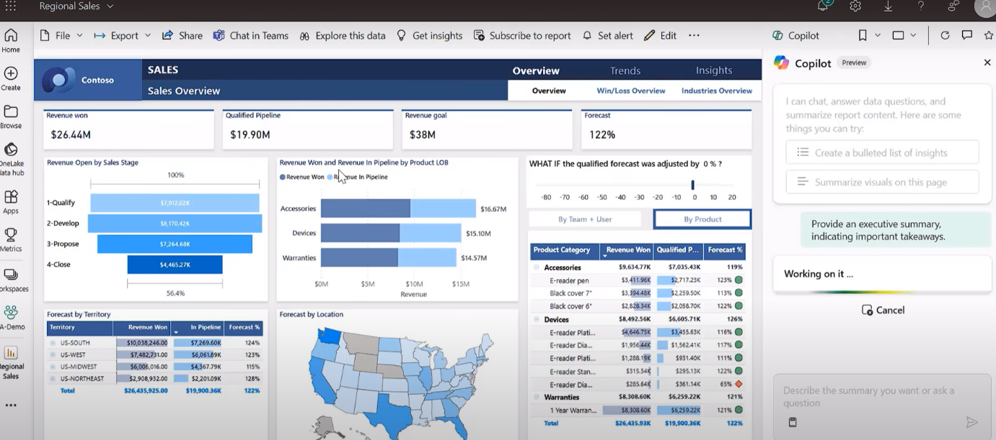

Here, you can see the summary of the whole report generated by copilot.

Another Example with some more insight.

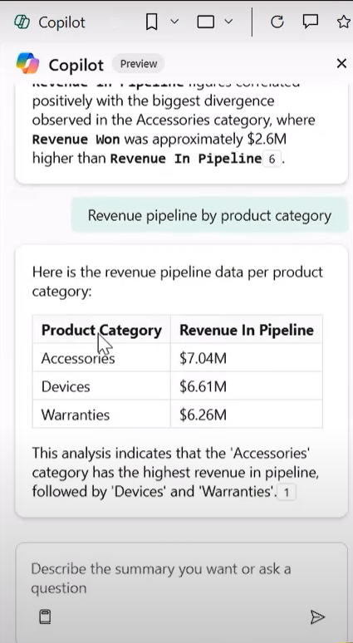

In Here, you can see the copilot has generated the insights as prompted by analysing the complete report.

By clicking the **1** icon present at the end it is the reference point to the visual from where the result is generated

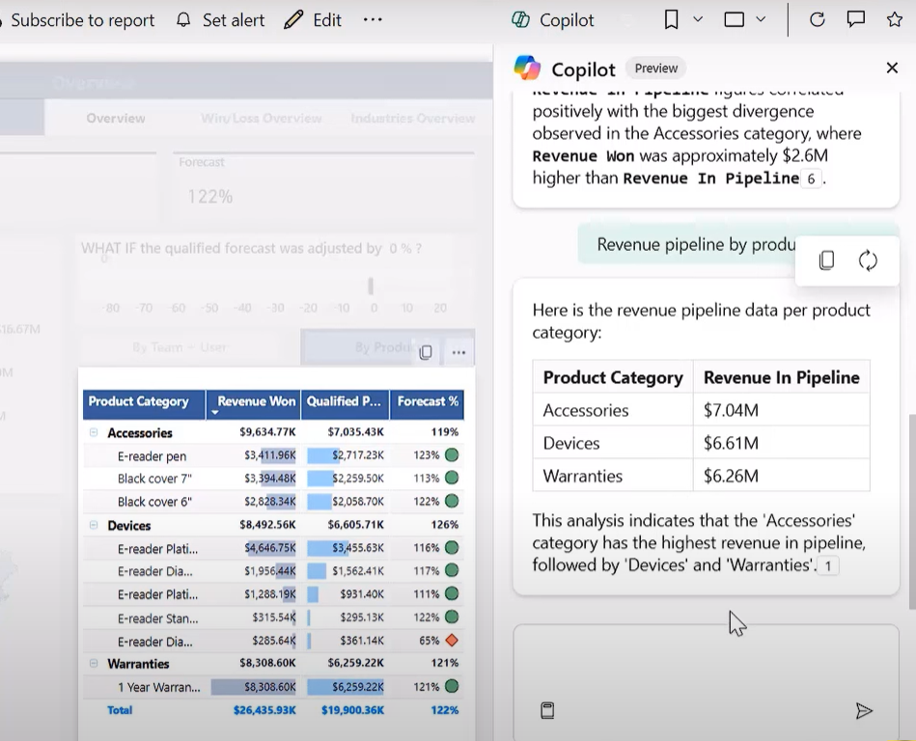

User can interact with Copilot and Define the summary of the report in Natural language, and it will result by analysing the report. So, ease.

When user has access to the sematic model, User can be able to generate his own reports using COPILOT.

Going into the sematic model and entering the model with Blank Report option

Enabling the copilot will helps you to build your own report as shown below

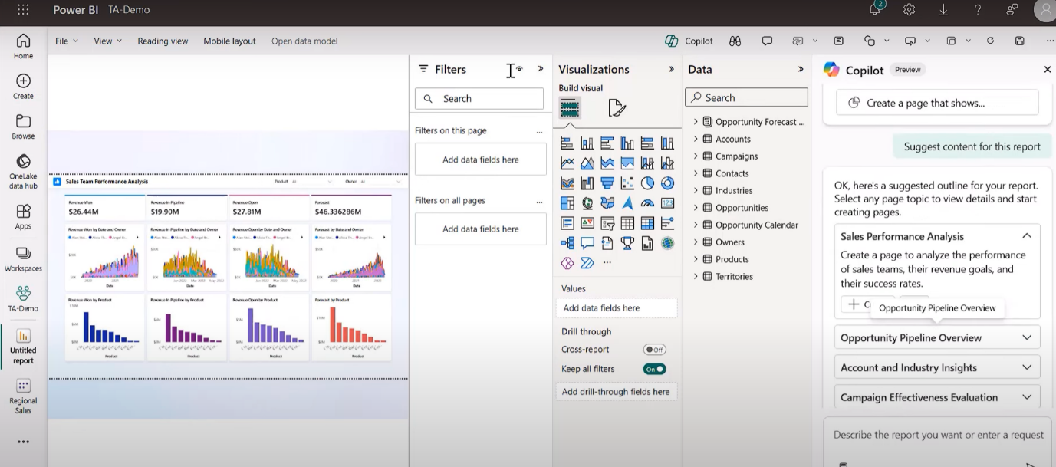

By analysing the data copilot has created a report of sales team performance analysis.

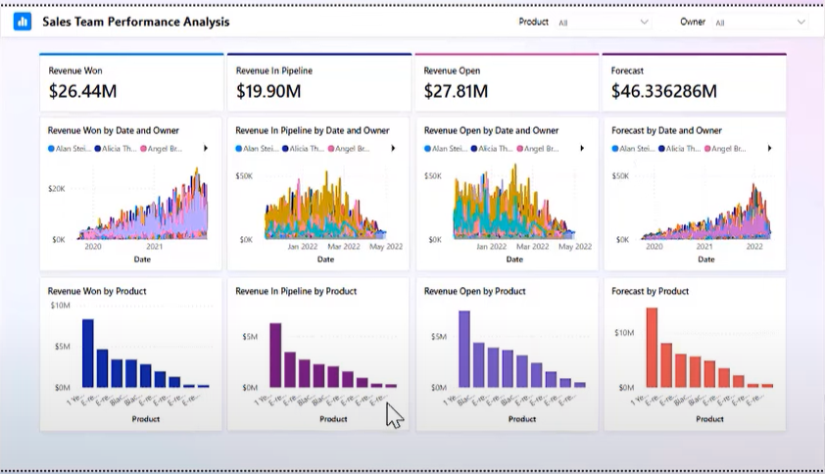

By defining anything with copilot we need to manually check whether the visuals are as required. Sometimes it may result additional visuals or KPIs.

**COPILOT for Developers**

To enable the copilot in the PBI Desktop

Open PBI Desktop application

Goto options and settings

Click on options

Goto preview features

Scroll down until you can see the COPILOT CHAT PANE IN REPORT VIEW

Enable it by clicking on the check box

After enabling the feature, the COPILOT option is available beside the publish button in the PBI desktop

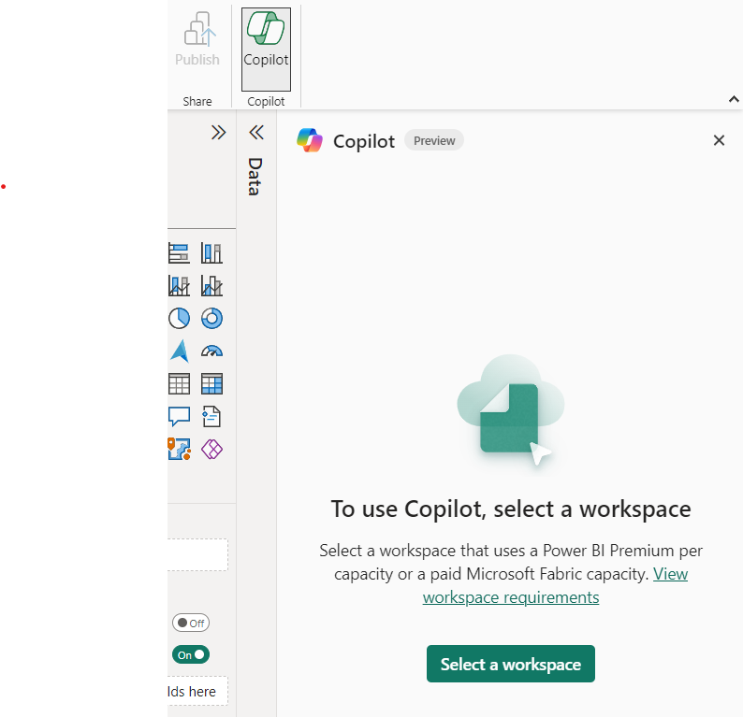

Clicking on the copilot will ask to assign the workspace with Fabric capacity or Premium capacity.

After getting the copilot into the Desktop, whatever the tasks assigned to the copilot will be tracked under the specific workspace.

The interface with the copilot is like the service copilot.

There are multiple features of COPILOT those can help the developers to improve their productivity.

By default, it shows two pre-defined functions as shown above.

As an example, you can see the instruction to create a page with different marketing campaigns present and about the dataset in the report will result as below.

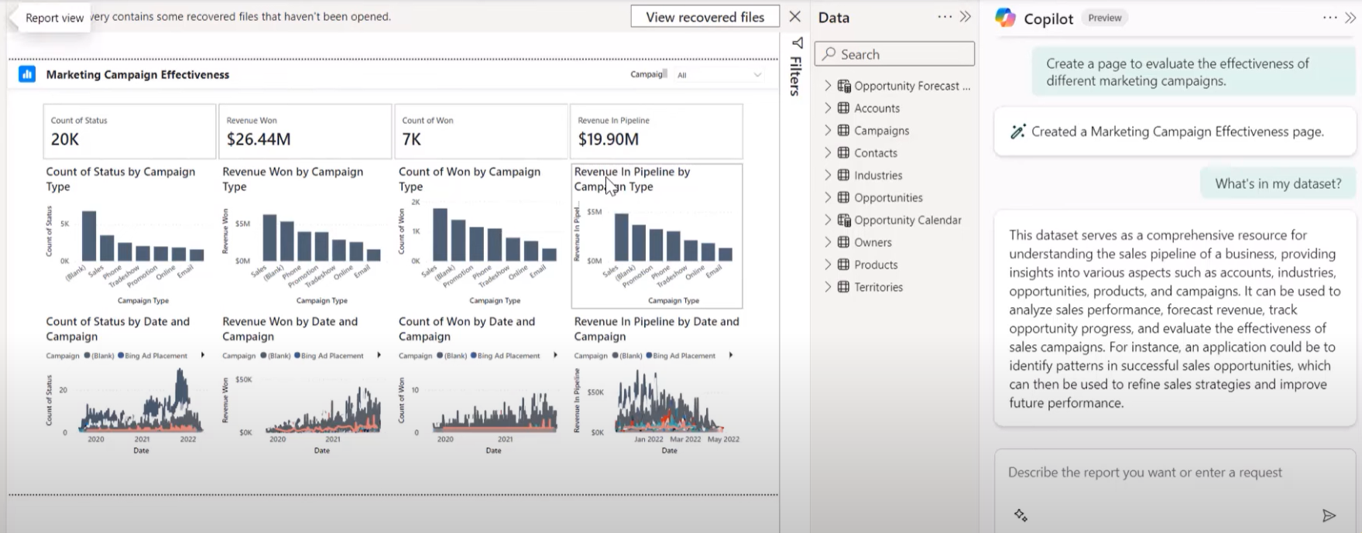

**Copilot in DAX Query view**,

As you were aware of COPILOT in DAX Query view you can perform complex DAX queries by using COPILOT.

In the Dax Query view we can be able to

Provide comments to DAX Queries

To create or to update the Dax measures

You can learn DAX queries by asking with COPILOT.

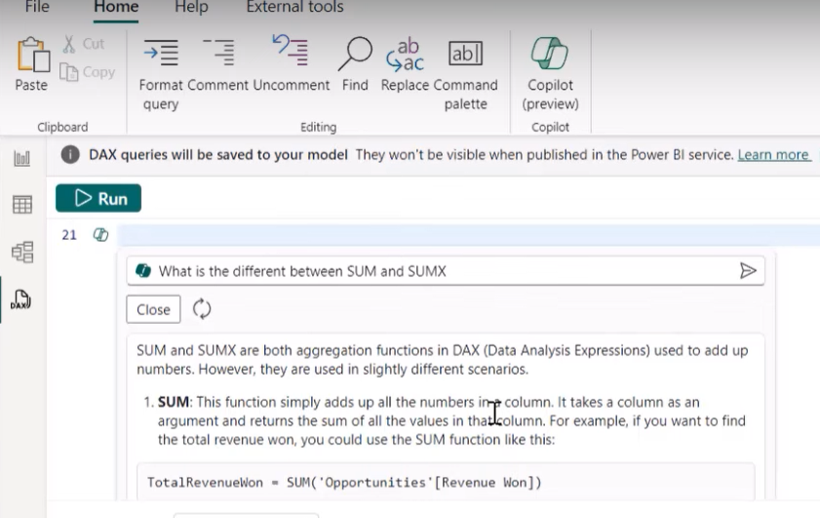

**Copilot in visuals as smart narrative**,

By dragging the smart narrative visual into the report box, you can be able to interact with copilot with some pre-defined options as shown below,

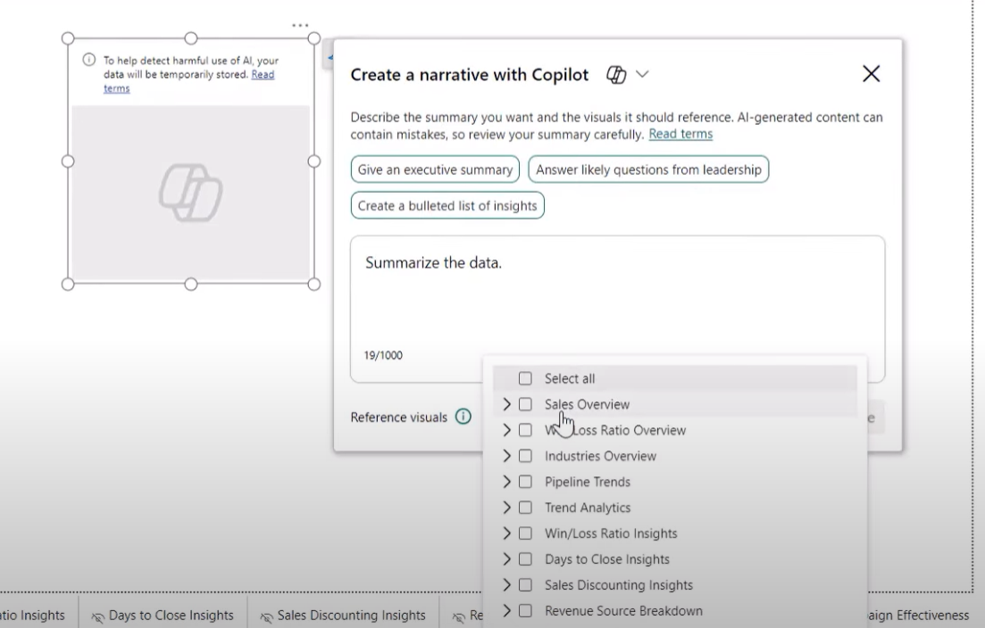

Here, I took an example for summarising the data and the result is below.

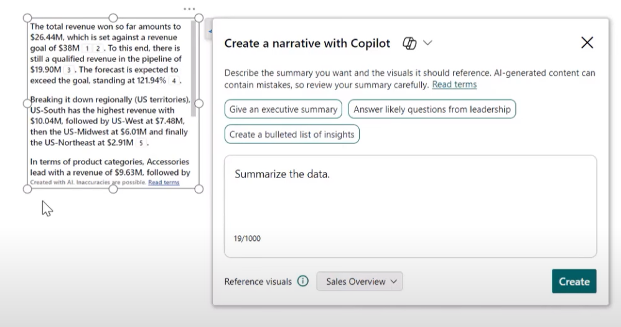

By hovering on the numbers **1 2** as referencepointsfrom where the visuals being used to narrate the statement.

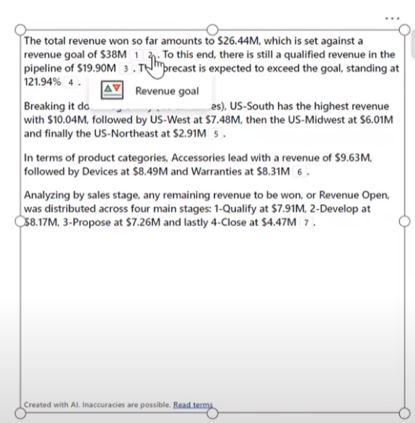

By clicking on that number will redirect to the visuals from which page it has generated from.

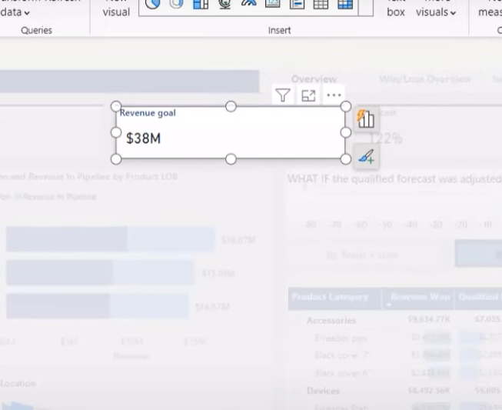

Another example as with some pre-defined function

Answer likely questions from leadership, the result you can see below

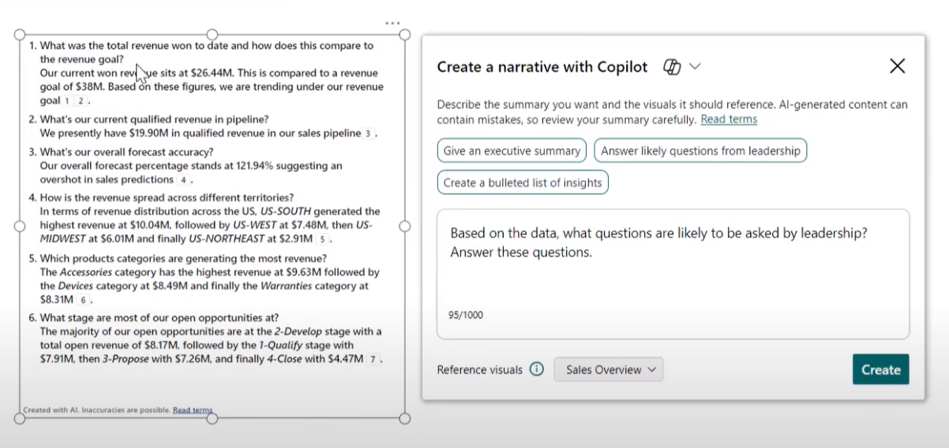

The Q & A visual is also integrated with copilot for adding synonyms to the visuals.

In tradition we’ve to manually enter the synonyms to the visuals on our understanding despite COPILOT will automatically get to the window where we can define synonyms for the visuals.

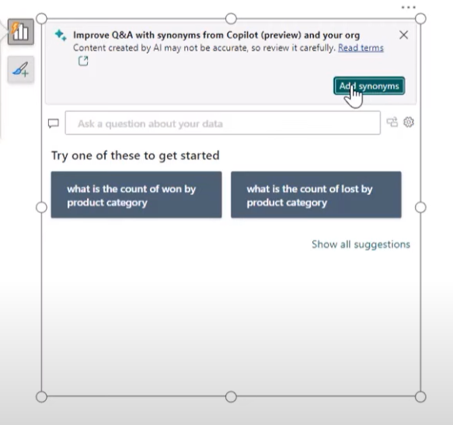

**Copilot for describing measures**.

In the model view we can be able to use copilot for describing measures.

By clicking on the copilot, it’ll automatically reads the DAX expression which has been used to create that measure and automatically describes the measure.

